Monochuck
An Approach to a one-handed controller
Landen Barber
5-22-2025

Oregon Institute of Technology

Approval of Signature

Student

X
Name: Landen Barber
Date :

Project Adviser

X
Name: Ganghee Jang
Date:

Table of Contents
Summary 4
Description 5
Background 5
Comparisons with existing approaches 6
Twiddler 6
Azeron 7
Xbox Adaptive Controller 7
3d Modeled Addons 8
ASCII Grip 8
Steam Index 9
Your novelty statement and design goals 10
Timeline and deliverables 12
Challenges anticipated and mitigation strategies 13
Parts availability / not arriving on time 13
Budget / parts breaking 13
Time management 13
Unexpected bugs / problems 13
Requirements 14
Functionality 14
One handed form factor 14
Modular Backside 14
Integrated chorded input 14
Remappable buttons /w app 14
Rumble/Haptic feedback 14
Ergonomic and tactile presence 14
System Level Design 15
Bluetooth connectivity 15
Low power and rechargeable battery 15
Low latency inputs 15
Ability to mimic other controllers 15
References 16

Summary
This document provides a description of my senior project and what it will entail. For my senior project I will design a one-handed accessibility controller aimed at expanding on the limited number of input options that a one-handed controller may have. There are a few central challenges to making this type of controller and many things to consider. Alongside the normal challenges like battery life, size constraints and connectivity/support for different applications, a one-handed controller is unique in that the physical number of inputs that can be implemented is cut short. Overall, the goal of this project is to have an intuitive one-handed controller that is easily customizable and aims to empower users with limited mobility to providing a device capable of connecting them to their machine.
As the controller will have both chorded input and contextual profile switching, the controller will come with an app to install drivers as well as allow the user to map buttons to whatever the user desires. These customizable features will be supported with real time visualization of inputs on the app. The controller will be able to be used either wirelessly or wired with seamless transitions between usb-c and bluetooth.
Throughout this document I will start by looking at the background of some other popular options for accessibility controllers as well as one that is very similar to my own and explain what makes mine different. I will then describe my timeline as well as the challenges and ways to mitigate and handle them. Finally, I will talk about the requirements that the final product should include.

Description

Background
Traditionally, controllers are designed for those with full use of both hands. While the standard controller can work for the majority of people, it can provide a barrier to those with disabilities or limited mobility. As Accessibility is becoming a more prominent aspect within technological and gaming spheres, there is a growing need for inclusive and specialized hardware. But, despite efforts by various companies, there remains a limited selection of intuitive, one-handed controllers that are compatible with many applications and games.
There are several previous technologies that have attempted to solve this problem before, but each comes with their own tradeoffs. One approach is the Azeron gaming keypad, which effectively acts like a mouse with finger actuated input. The mouse input on the controller allows for more precise aiming and works well with a computer system, it also comes with extensive customization options. Another approach that is very similar is the Twiddler. The twiddler is a one-handed keyboard that includes chorded input. The biggest problem with this is that it is meant for typing and is primarily meant for use by a tablet or other mobile device via Bluetooth. Both of these products demonstrate different aspects that I would like to bring together in order to create a more suited device toward gaming.

Comparisons with existing approaches

Twiddler
While both my project and the Twiddler use chorded input within a one-handed form factor, the purpose and audience for each one differ fundamentally. Twiddler controllers are optimized for entering text quickly and efficiently and are not aimed toward those with disabilities. To lay out all of the differences, Twiddler keyboards have 12 remappable keys (but not all of them, limiting accessibility), an optical mouse, is not ambidextrous, no haptic feedback, meant for a niche text-entry focused audience, and is compatible with mobile devices and text programs on computers. My planned controller on the other hand will be fully remappable, ambidextrous by design, it will include haptic feedback and is directed towards a more general audience with compatibility meant for both general use and some gaming. Unfortunately, I will not be including an optical mouse, making it slightly different. For reference, the latest iteration of this controller costs 229 dollars.
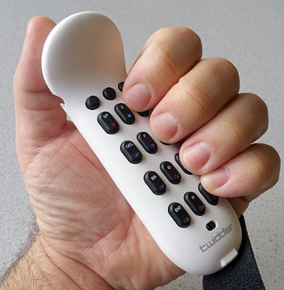

Steam Index
Another similar product would actually be Steam index controllers. One of the biggest differences though is that these are a set of controllers that could theoretically be used with one hand but are meant to be duel wielded. The steam index controllers are VR controllers that, because of steam drivers, have the ability to completely remap buttons and swap between control schemes for different games, and are virtually compatible with most steam games through their software. Other additions include the ability to track which fingers are holding onto the controller, can measure the grip force of the user, haptic feedback, and is wireless with external motion tracking. Compared to my project, it has many comparisons to the accessible software I want to include, like the contextual profile switching and button mapping, but is fundamentally different by being two handed and having many features that are not necessary for general use and would drive up the cost.
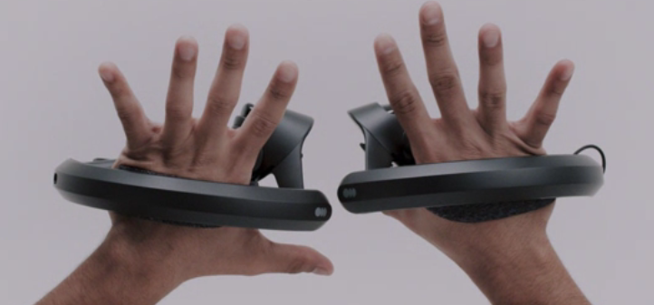
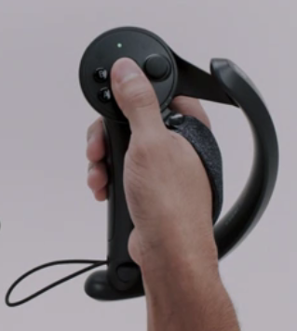

Azeron
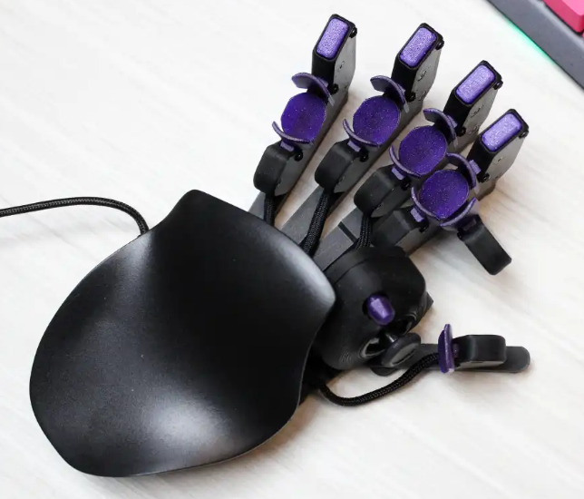
Azeron controllers are a bit different to the type of approach I will be using, as they are closer related to mice, they also have finger actuators to allow another degree of freedom in controlling a computer. The difference with it compared to this project is that it has less input without the chorded input, it is also less mobile than a gamepad and only works with PC’s.

Xbox Adaptive Controller
Another approach is the Xbox adaptive controller; this is a flat controller that has buttons and many inputs. Unlike other controllers though, it functions to brain that many other accessibility devices can be connected to and be used in conjunction with each other by providing an interface for people who are less tech savvy and need to set up multiple devices.
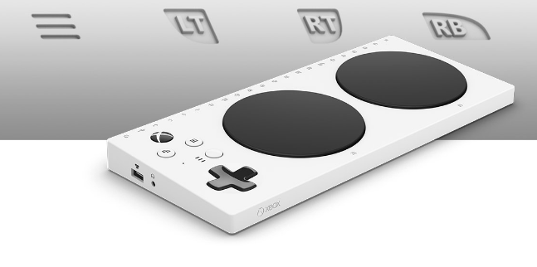

3d Modeled Addons
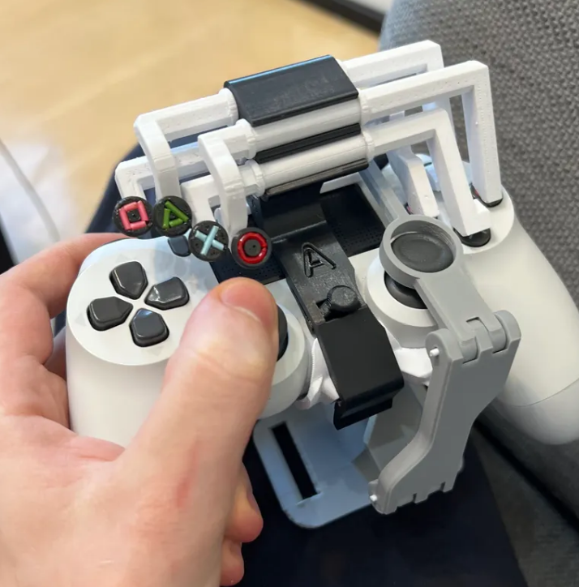
The simplest and cheapest approach to this problem would be the many different models that you could 3d print on your own, to convert a standard controller into one that is usable with one hand. These are good options for those with access to a 3d printer. The biggest problem with this is that they are limited to the software originally designed for the controller that is converted, it also makes the controller much less ergonomic and difficult to use and assemble.

ASCII Grip
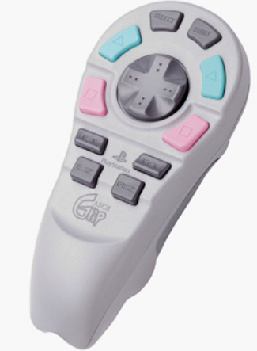
Another controller to note is the ASCII grip controllers, which is a similar approach to a one-handed controller but is much older by comparison, being made for the ps1. It has some customizable buttons, and a similar one-handed form factor, and because of its ambidextrous design, there are no buttons on the back to make use of that space. Of course, with being such an old controller there isn’t much support for this specific controller either.

Your novelty statement and design goals
What makes my project unique is the inclusion of chorded input and contextual profile switching, meaning that depending on the application that is in focus, different control schemes can be applied. Unlike tools like the Twiddler, this will have a bigger focus on general use and usability for applications like games. My goal is to expand on the concepts displayed in controllers like this, and to build one that is powerful and intuitive enough to be used any time, across a variety of platforms and applications. The inclusion of chorded input, activated by a toggle or hold-to-use button, enables users to expand their range of commands without over complicating the design or compromising the ergonomics of the controller. Additionally, the controller features a modular, removable backplate with mirrored button and grip layouts to provide true ambidextrous support, a feature rarely considered in similar devices.
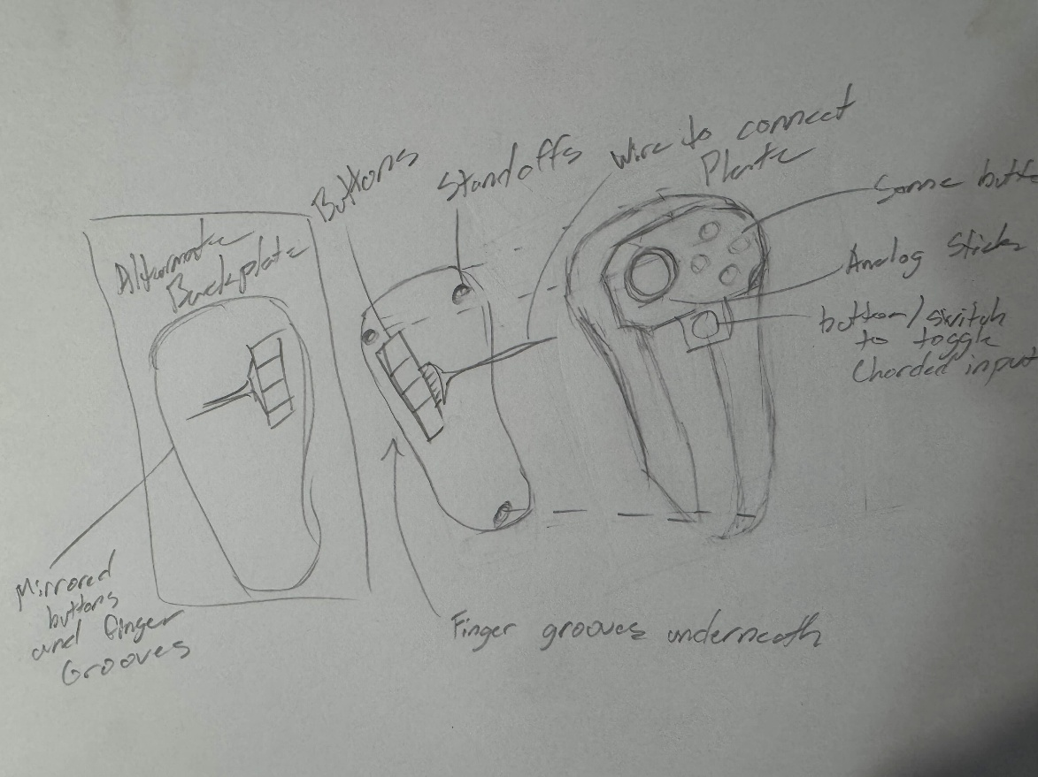
Accessibility controllers are often treated as specialized devices meant for those with disabilities, whether it’s due to injuries or chronic conditions, I think that there is a place for a more fully integrated solution that could be used by a more general audience. Many existing technologies are either too expensive, too complex, or specialized to be used by more than just the intended audience, and by making a controller that is both intuitive and powerful, this project can fill in this gap in the market. Accessibility should not be a subset of devices, but something that should be expected to be supported by everything.

Timeline and deliverables
The timeline of this project will be to complete it within the next school year. Fall term will be the time to design the project, including specific technology, and initial modelling of the controller for 3d printing. Technologies chosen will have to be carefully planned in order to fit a chosen form factor and have enough stats to run smoothly. As far as the 3d modelling goes, ideally it would be nice to have a print before winter term starts, but this will depend on how long each part takes to arrive, as I want to double check measurement and not have to print more prototypes than I need.
Winter term will be spent building, assembling, and coding. At this point I should have all the parts aquired and will need to finish testing each one and building the controller, which may take a month to fully flesh out the design. The goal of the term will be to have a working prototype by the end of it. The first few weeks will be primarily spent building the controller and writing te foundational code for the software. I will then move to focus more on the program and app as this is a significant piece of compatibility and functionality. The end of the term will be spent trying everything together in order to have a working prototype.
Finally, spring term will be spent testing and documenting. More hardcore testing will be used to help complete the prototype and bring it closer to 100% completion. The prototype should be completed by idea fest as it will be presented to the public. Documentation should take place throughout the entire year, but the end of the term will be spent writing the user manual as well as the project documentation to completion.

Challenges anticipated and mitigation strategies

Parts availability / not arriving on time
Packages going missing or being delayed may delay the entire project depending on the part that is stuck. In order to prevent this from happening, I will find multiple available sources for a part in order to avoid that point of failure. As I will be ordering to an apartment, I will also keep track of delivery days in order to not have any packages stolen. Worst case scenario I will find a more reliable place to order parts.

Budget / parts breaking
In the event of unexpected price increases that exceed my budget, I will keep in mind a contingency fund to help cover those costs. I will need to track expenses regularly as well as find lower cost alternatives and secondhand parts if needed.

Time management
As this is a solo project, balancing the project load with other coursework and other obligations may cause delays, in order to mitigate this, a realistic timeline should be written beforehand to plan for buffers of time. To stay on track, reviewing progress of the project will help adjust any plans as necessary.

Unexpected bugs / problems
In the case of problems surfaces through testing and debugging, it will be important to handle these bugs as they occur so as to be able to isolate them more effectively.

Requirements

Functionality

One handed form factor
The controller will be meant to be used with one hand as a base and must be comfortable to hold while housing most of the other components. This is essential as this defines the purpose of making this controller.

Modular Backside
To make the controller both ambidextrous and still comfortable, a replaceable backside will be implemented to swap between hand positions. This will allow the controller to be more accessible without requiring a second device.

Integrated chorded input
There will be another button/switch to enable chorded input allowing more control over the number of mappable buttons. This solves the challenge of having too few inputs and adds to the customizability of the device.

Remappable buttons /w app
A controller needs customization so an app will be used for the user to change the mapped buttons to whatever is desired. There will be both axis input and buttons. This will ensure adaptability to many more games or software that would otherwise be unfeasible.

Rumble/Haptic feedback
To make it more compatible with other controllers, haptic feedback and rumble will also be added to make it more fluid to use. It also adds to the functionality of the controller making it more complete.

Ergonomic and tactile presence
The controller should be comfortable to use during longer sessions, and the buttons should be easy to distinguish as they may be close together. This is important to add to the usability of the controller.

System Level Design

Bluetooth connectivity
Since the controller can be wireless, we will need Bluetooth to connect to the source to be controlled. This is an indispensable feature for any modern controller.

Low power and rechargeable battery
Since the controller should be wireless, it will need a battery and has the ability to charge while using. It cannot be Bluetooth without this functionality.

Low latency inputs
A controller will need low latency input to make it feel usable. With many buttons and pieces to control, the code will need to be written in a way to be quick. This is especially important in allowing someone to play games with the controller.

Ability to mimic other controllers
To add compatibility to many sources, the controller should be able to mimic something like an Xbox controller which already has native support for many games. This will limit the number of drivers needed and adds to the usability of the product.

References

Azeron. (n.d.). Azeron – Game controllers for PC and consoles. https://www.azeron.eu/

Microsoft. (n.d.). Xbox adaptive controller. Xbox. https://www.xbox.com/en-US/accessories/controllers/xbox-adaptive-controller

Kuumeri, A. (2022, January 30). One-handed DualShock 4. Printables. https://www.printables.com/model/126646-one-handed-dualshock-4printables.com+5reddit.com+5reddit.com+5

Heckendorn, B. J. (n.d.). Single-handed Xbox One controllers. Benheck.com. Retrieved June 11, 2025, from https://www.benheck.com/controllers/

OneSwitch.org.uk. (n.d.). One handed game controllers. Retrieved June 11, 2025, from https://oneswitch.org.uk/page/one-handed

Walker, J. (2014, May 1). ASCII Grip One-Handed RPG Controller Review (PlayStation). 1 More Castle. https://www.1morecastle.com/2014/05/ascii-grip-one-handed-rpg-controller-review-playstation/

Valve. (n.d.). Valve Index Controllers. Steam. Retrieved June 11, 2025, from https://store.steampowered.com/app/1059550/Valve_Index_Controllers/

Tek Gear. (n.d.). Twiddler 3 one-handed wearable keyboard & mouse. MyTwiddler. https://www.mytwiddler.com/

Akaki Controllers. (n.d.). Akaki Controllers. Retrieved June 12, 2025, from https://akaki.co/

Evil Controllers. (n.d.). Accessible controllers. Evil Controllers. Retrieved June 12, 2025, from https://www.evilcontrollers.com/store/accessible-controllers

